What is Dynatrace? and Its Dynatrace Monitoring Architecture

Dynatrace architecture video screenshot and link description in image – Explain 2 min

Dynatrace Design: 3-4 mins
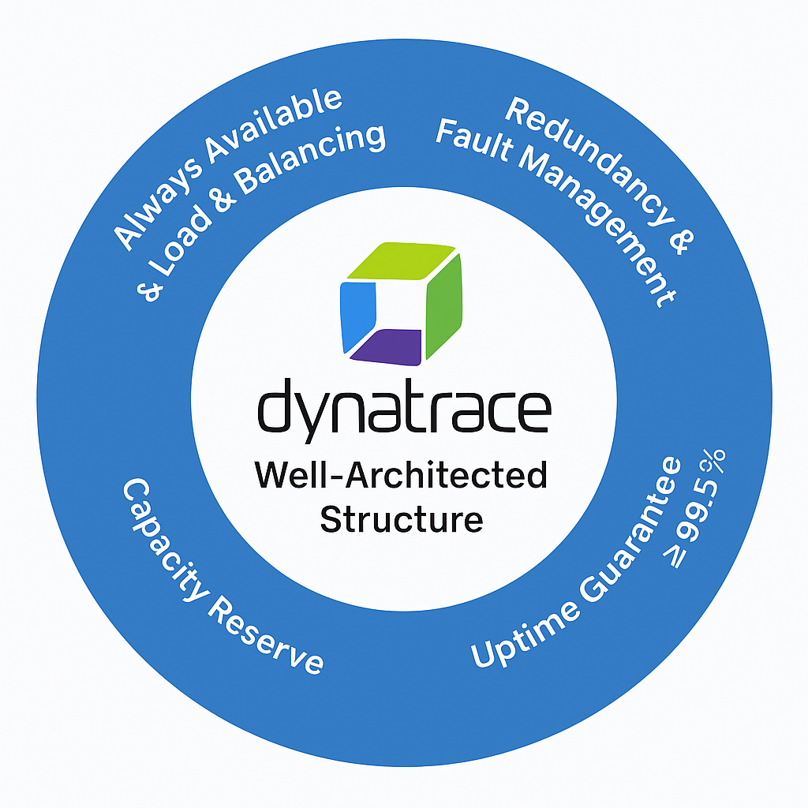
Dynatrace - built on an elastic grid architecture - scales to 10L+ hosts easily
Elastic Grid Architecture = scalable, distributed, fault-tolerant system that adapts to demand and ensures continuous availability.
• Always Available: Runs on AWS, Azure, GCloud -min 3 availability zones per region
• Scaling & Load Balancing: Automatic instance spin-up for traffic spikes
• Redundancy: Real-time failover built into all components (backup component)
• Fault Management: Automated detection & replacement of faulty components
• Capacity Reserve: 1/3 excess capacity for failover & peak loads
• Uptime Guarantee: ≥ 99.5%

Dynatrace monitoring Architecture – 7min
Just think of input and processes and gives output,
Input /Ingest - Metric data and Logs – metadata, trace, logs, topology, code Events
System -Dynatrace – Processes It is using its components
Output – Observability data and Metrics, Visualization for analysis and Alerts and automation and much more as shown in images
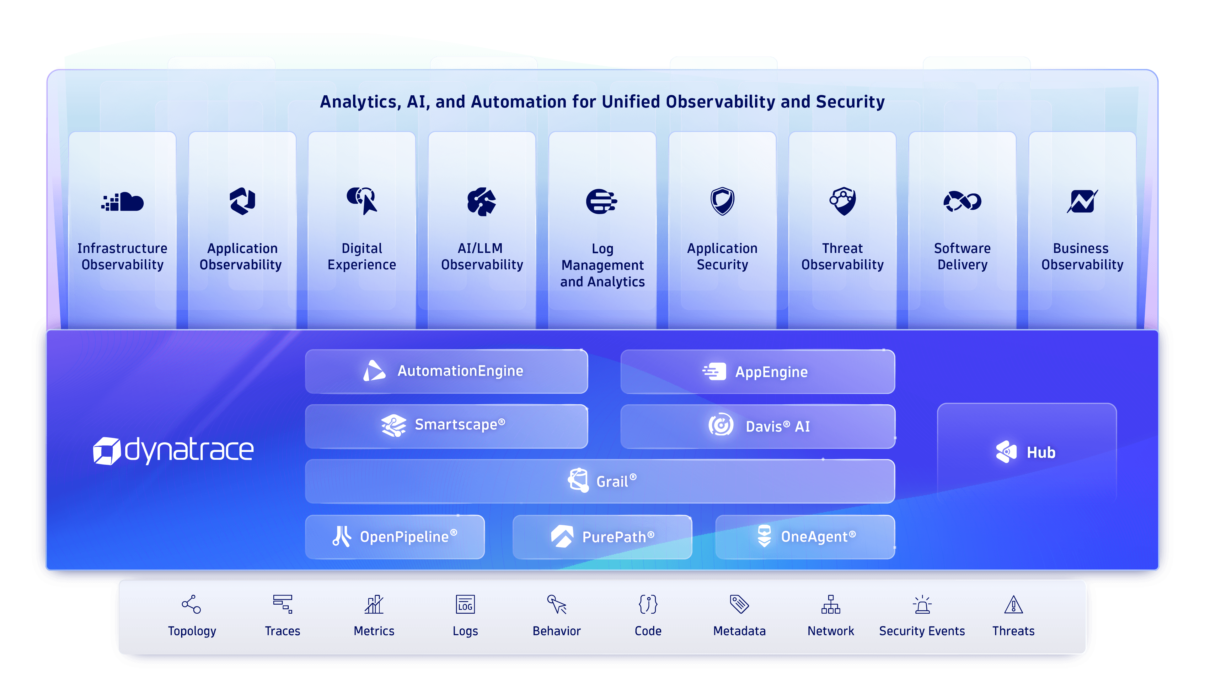
App Engine:
build custom apps on top of all the observability data collected by Dynatrace.
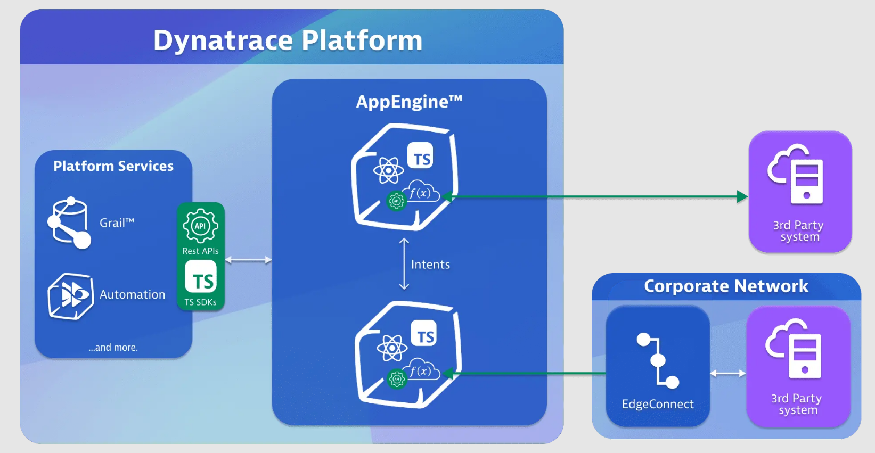
Automation Engine: Workflow app is powered by this engine
• Targeted Notification & Collaboration → Connect teams and share real-time answers.
• Closed-Loop Remediation → Auto-remediate issues and vulnerabilities.
• Quality & Security Gating → Stop vulnerabilities before production.
• Continuous Vulnerability Assessment → Detect zero-day threats continuously.
• Predictive Automation → Perform maintenance before failures occur.
• Progressive Delivery Orchestration → Release based on feedback for safety.
• Intelligent Infrastructure & App Orchestration → Auto-scale and optimize loads.
• Preventive Security Configurations → Block malicious IPs proactively.
• Predictive Capacity Management → Forecast shortages to prevent outages.

Davis AI
- Davis® AI is Dynatrace’s AI causation engine. Detects performance anomalies in apps, services, and infrastructure.
- Alerts on abnormal situations like performance degradation, functionality issues, or downtime.
Key Use Cases
- Real-time anomaly detection using static, adaptive thresholds or AI models.
- Automated root cause analysis for quick fixes.
- Error retracing to understand problem evolution.
- Custom dashboards via DQL for personalized health views.
- Davis® causal correlation analysis
- Davis® forecast analysis
- Seasonal baseline

Grail
DT’s data Lakehouse for observability - Stores logs, metrics, traces, events
Data Organization → Uses buckets, tables, and views for structured storage
DQL (Dynatrace Query Language) → Query and analyze data efficiently.

Openpipeline:
OpenPipeline is Dynatrace’s data handling solution for seamless ingestion and processing of data from any source, at any scale, and in any format.

